Guidelines for making student books
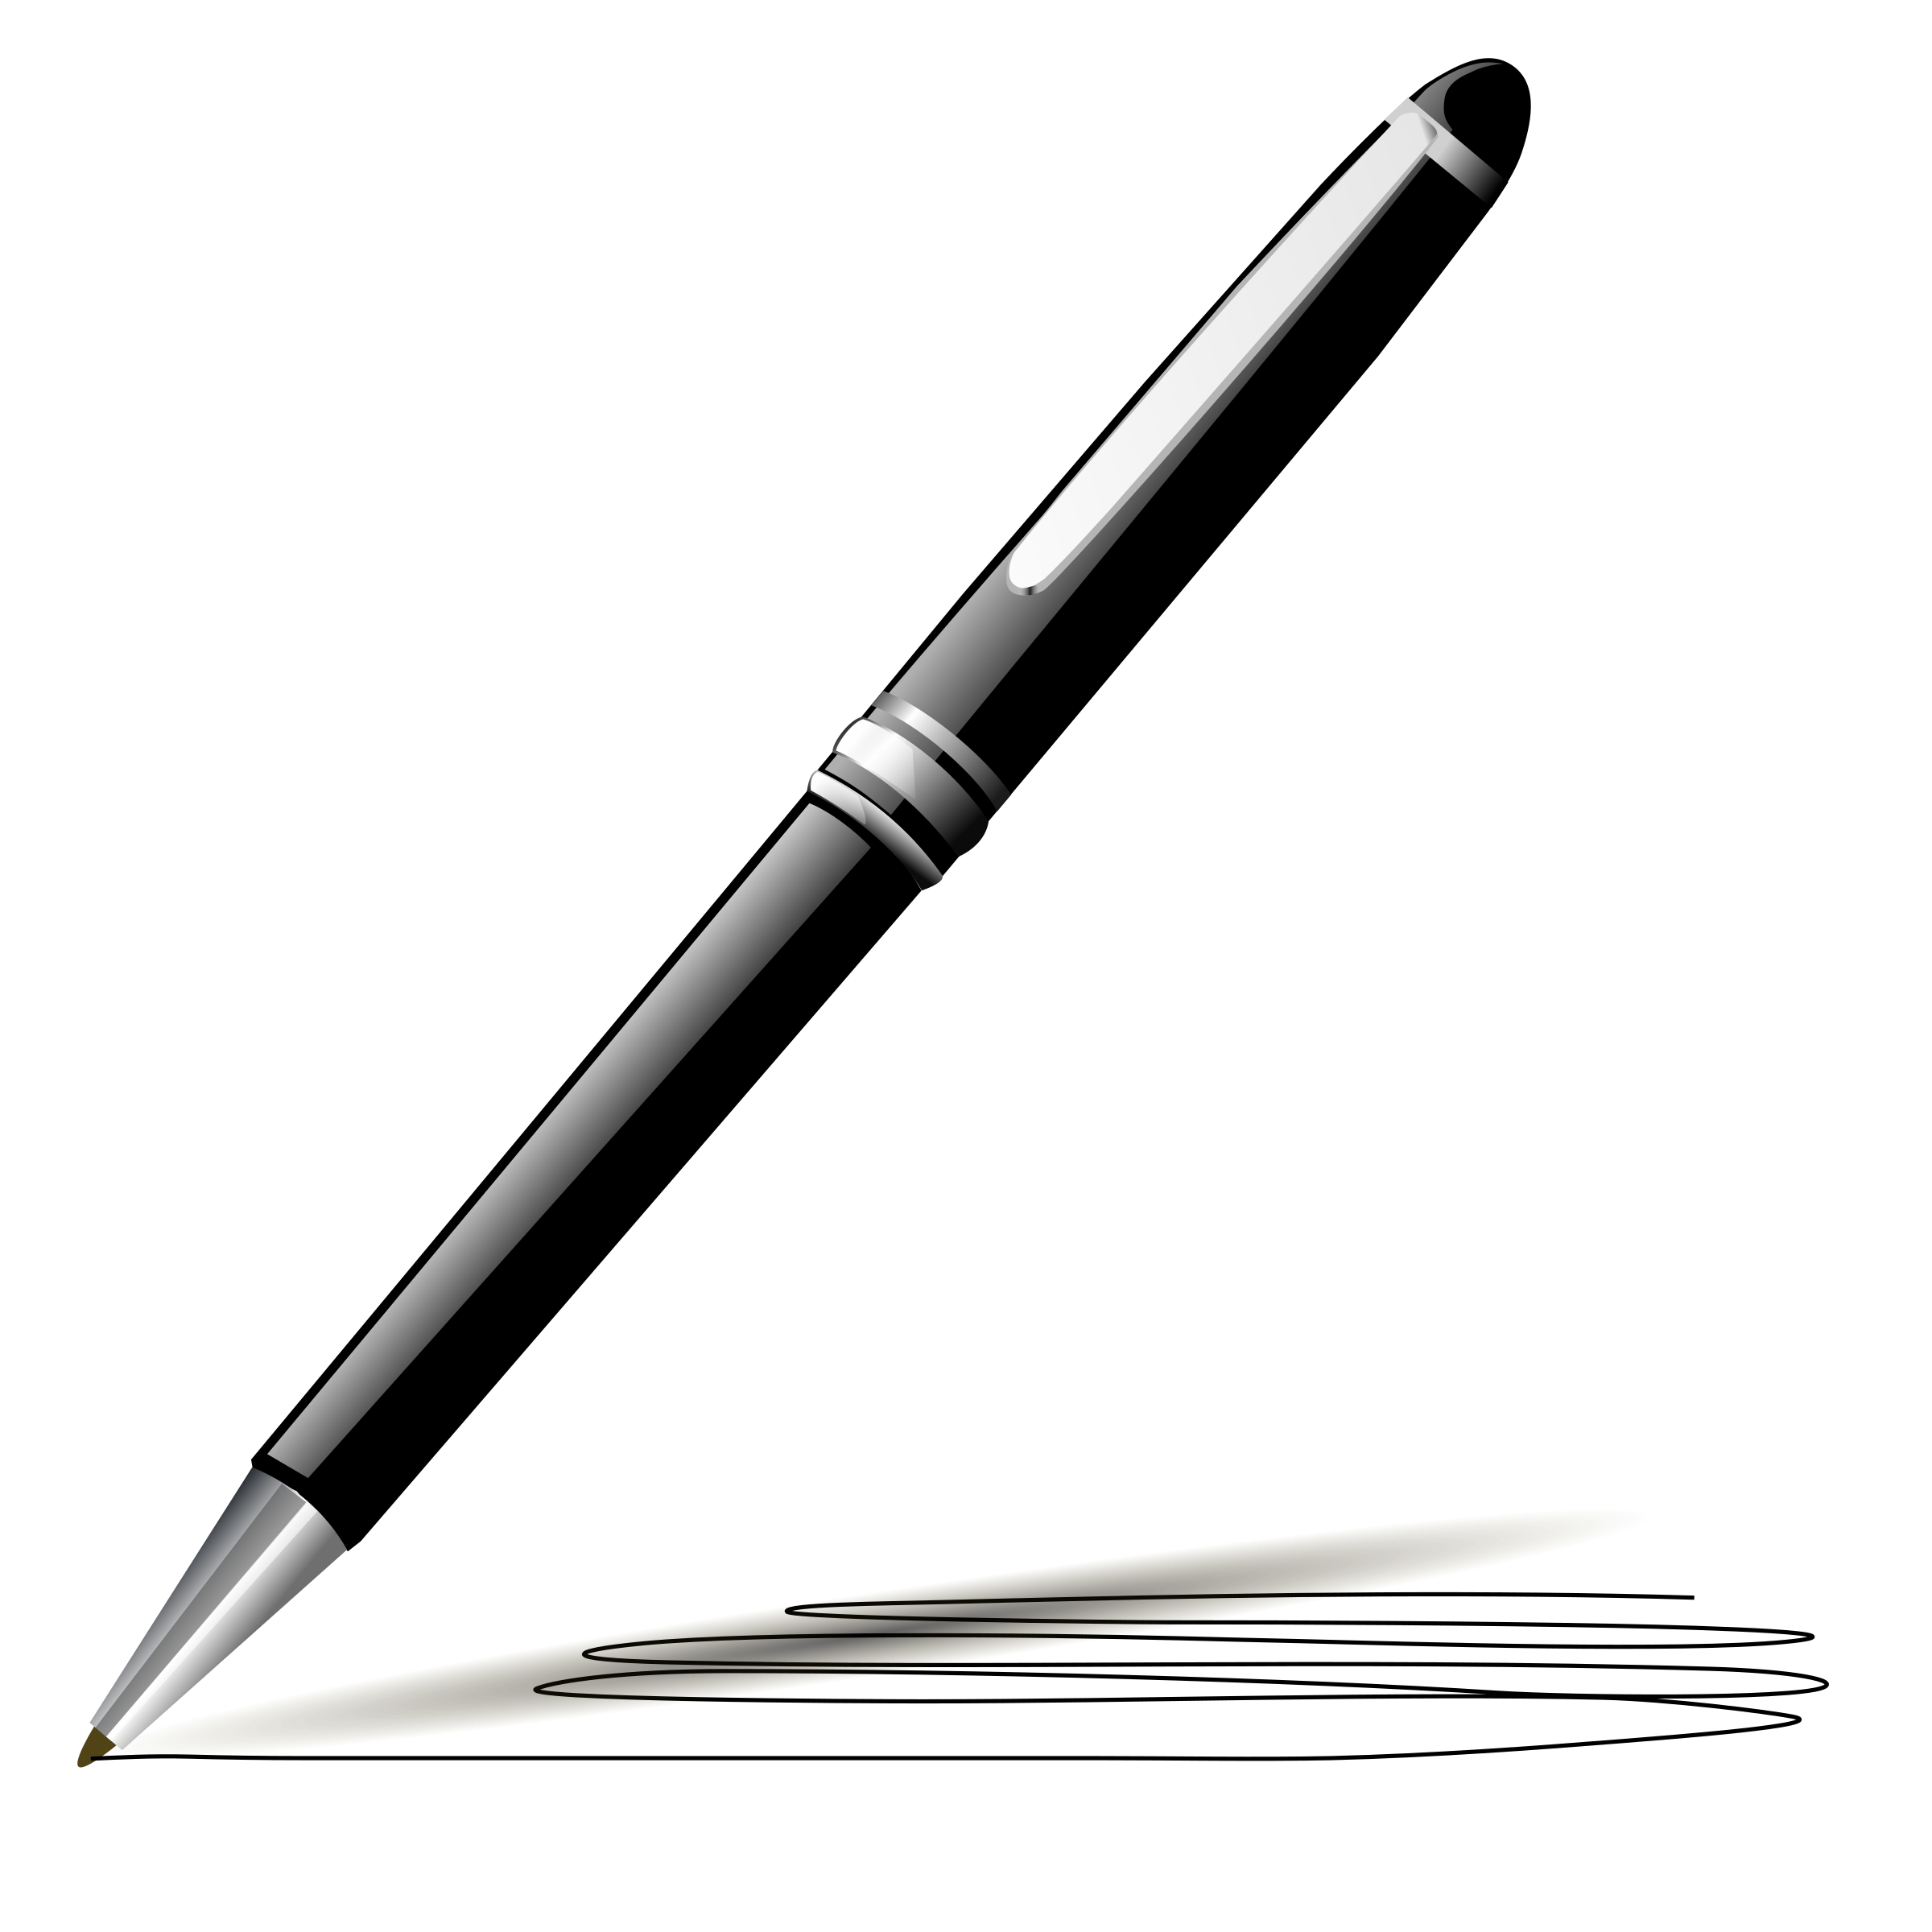

The following guidelines will assist you in planning for the Fair:

1. All students grades K-12 are eligible to participate.

2. Only one individual book per student may be submitted; however, one class
or group book may additionally accompany your individual student entries.

3. Entries may be fiction or non-fiction in prose, poetry, or drama form.

4. Manuscripts must be in book form. Front and back covers may be made from
construction paper, cardstock, cardboard covered with fabric, contact,
wallpaper, or other similar materials.

5. Books are to be written under the supervision of classroom, resource, or homeschool teachers.

6. Each book must have a title page or sticker in the front of the book to ensure
that misplaced books can be identified and promptly returned to the correct
school sites. The following information is required:

Author's Name ___________________________________Grade level______
Illustrator's name _________________________________ _
Teacher's name _________________________ Date of Publication________
School ___________________________ School District_________________

to emphasize the importance of writing while providing a wide audience to
share your students' published works. This is not a contest to see which
school has the best displays. The displays are to showcase student books.

8. Each participating teacher and/or school is responsible for delivering and
picking up their own books. Books should be delivered to Beale Library, 701 Truxtun Avenue, Bakersfield, in the hallway near the auditorium on Friday, March 8 between 3:30 and 5:30 pm. Books must be picked up Saturday, March 9 between 12:00 and 1:00 pm.

PLEASE DO NOT BRING BOOKS ANY EARLIER

9. Parents of young authors are responsible for transportation and supervision
of their children on the day of the fair unless your school district has made
other specific arrangements.

10. We encourage teachers to send the parent letter home at least one week
before the Fair to help promote attendance of this event.

