Kern Reading Association, in conjunction with The Wonderful Company, Beale Library, and Kern Literacy Council
Presents The Young Authors’ Fair
Saturday, March 9, 2024, 10am-12
Beale Library Auditorium
Free & open to the public
- Student created books on display.

- Each student who creates and displays a book will be recognized with a Young Author sticker/ribbon.
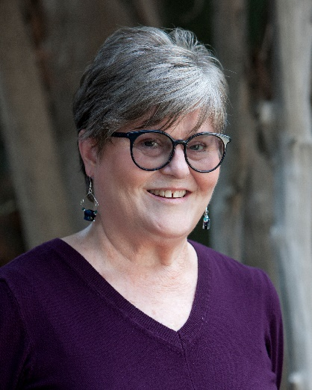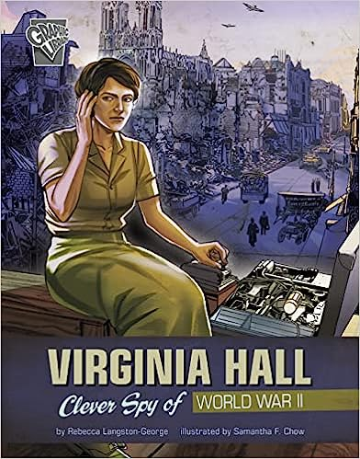
- Local author Rebecca Langston-George will give a presentation for children on her books and writing.

- Each family in attendance will receive one FREE signed copy of her graphic novel Virginia Hall: Clever Spy of World War II courtesy of The Wonderful Company.

Schools wanting to display books should visit www.kernreadingassociation.org and click Young Authors Fair to send in a registration form. Book displays must be set up the night before on Friday, March 8 from 3:30 to 5:30 and require pre-registration.
For more information contact Kern Reading Association President Brenda Russell at silkyterrier2@att.net

