Writing and Bookmaking
Professional Development
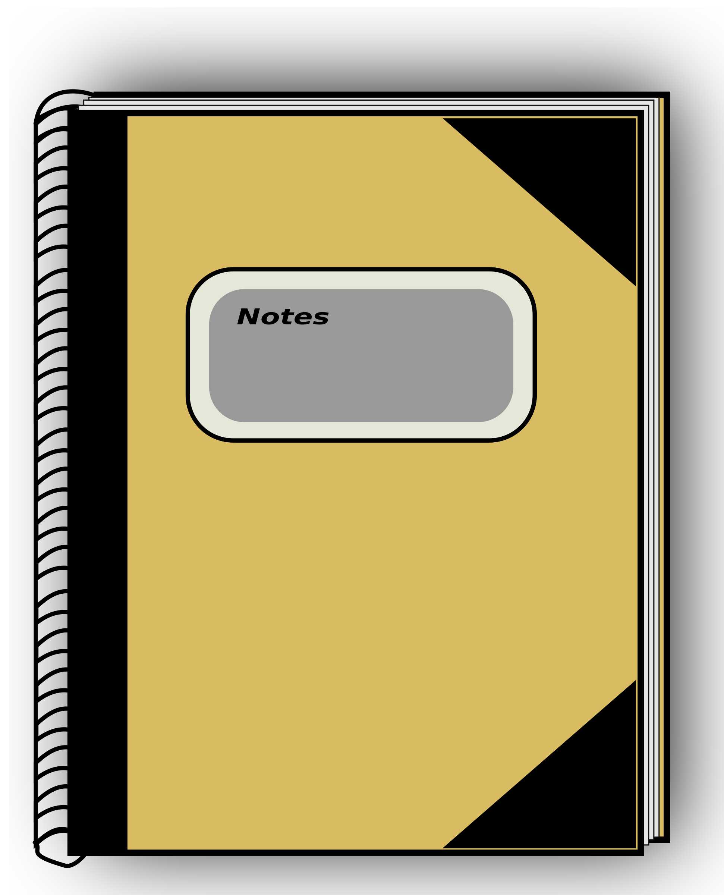

To register please complete this form and email to
silkyterrier2@att.net or mail to: Kern Reading Association
Attn. Brenda Russell
PO Box 10837
Bakersfield, CA 93389-10837

(If mailing, please mail by 10/27/2023 to ensure available supplies.)

Name: _______________________________________________________

Address: _____________________________________________________

Phone: ______________________________________________________

School: ______________________________________________________

District: ______________________________________________________

Work Phone: ___________________________

Grade Level(s): ________________________

I am interested in becoming a KRA/CRA member. Yes ____ No ____

